《PhysicsⅠ》课程期中考试试卷
开课学院：理学院 考试形式：闭卷 允许带非存储计算器、纸质词典入场
考试时间:2010年 5月6日 所需时间100分钟

姓名 专业 学号 组号
I. Multiple-choice: (there is one correct answer only)
1. A stone is thrown horizontally and follows the path xyz. The direction of the acceleration of the stone at point y is:
A．↓
horizontal
x
y
z
B．→
C．↘
D．↗

2. An object is traveling around a circular orbit with a 12m radius. At one instant its speed is 6m/s and is increasing at 4m/s². At that instant the magnitude of its acceleration is:
A．2m/s². B．3m/s². C．4m/s². D．5m/s²

3. An object is moving in x-y plane with a motion function of 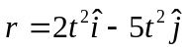, the object is
A．Moving in a line
B．Moving not in a line
C．Moving with constant velocity in a line
D．Moving with constant speed in a line

4. A particle moves in x direction, it starts from the original position with a velocity of v₀=2. The acceleration of the particle is a=6v (v is the velocity of the particle). The motion of the particle is dependent on
A. 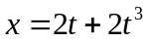 B. 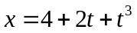.
C. 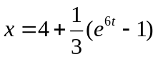 D. 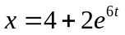
5. A particle moves in x direction, it starts from the original position with a velocity of v₀=4. The acceleration of the particle is a=3+2x. The velocity of the particle, at x=2, is
A.4 B.. C.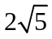 D.6
6. A particle moves in a circle with radius of R=0.0625m, its motion is dependent on 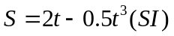. The magnitude of its acceleration, at t=1s, is
A. 3 B. 4. C. 5 D. 6
7. An object is moving in x-y plane with a motion function of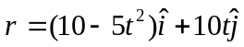, the magnitude of its tangential and centripetal acceleration at t=1s is
A.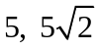 B.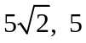. C.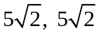 D.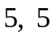
8. A 2kg particle is acted by a conservation force and starts to move from original point along the x axis. The potential energy, relative to the conservation force, is given by U(x)=2x²-3x⁴, where U is in joule and x is in meter. When the particle is at x=1.0m, its acceleration and velocity are
A. 4 m/s², 1 m/s B. -4m/s², 1 m/s C. 4m/s², 2 m/s D. -4m/s², 2 m/s

9. A wheel starts from rest and has an angular acceleration given by α(t)=6t², where t is in second and α is in radians per second-squared. After it has turned through 10rev its angular velocity is:
A．63rad/s. B．75rad/s. C．89rad/s. D．130rad/s.

10. A small ball with mass m and radius r from rest at the position shown and rotates
without slipping along the loop track of radius R (R>>r). What is the smallest value of y such that the ball will rotate without losing contact with the track?
m, r
y
R
A. 2R B. R/2
C. 7R/10 D. 3R/4
11. A 4.0kg solid wheel, rolling without slipping on a horizontal surface, has a rotational inertia about its axis given by MR²/2, where M is its mass and R is its radius. A force is applied to a point R/3 away from the axle and the center of mass has an acceleration of 2.0m/s². If the direction of the applied force is positive, the applied force and the frictional force between the wheel and ground are
A. 6.0N, 2N.
F
B. 6.0N, -2N
C. 9.0N, -1.0N
D. 9.0N, 1.0N
12. A small satellite is in elliptical orbit around the earth as shown. If L denotes the magnitude of its angular momentum and P denotes linear momentum:
A. L₂>L₁ and P₂>P₁;
L₁ , P₁
L₂ ,P₂
B. L₂>L₁ and P₂=P₁;
C. L₂=L₁ and P₂<P₁;
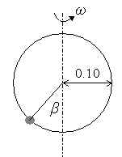
D. L₂=L₁ and P₂>P₁;

13. A small bead can slide without friction on a circular hoop with a radius of 0.10m in a vertical plane. The hoop rotates at a constant rate of 4.0rev/s about a vertical diameter, as shown in the figure. The angle β, at which the bead is in vertical equilibrium, is
A. 80° B. 81° C. 82° D. 83°
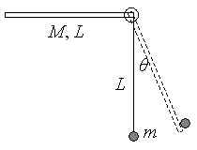
14. A uniform rod of length L and mass M is supported by a hinge at one end and is free to rotate in the vertical plane. The rod is released from rest in a horizontal position. A particle, with mass of M/3, is supported by a thin string of length L from the hinge. After the collision, the rod turns together with the particle, the maximum angular θ_{max} is
M/3
max
A. 40°
B. 45°
C. 50°
D. 55°

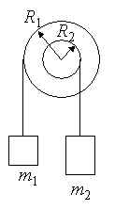
15. Two wheels rotate together about a common axis. The total moment of inertia of the wheels is 40kgm². Two objects are attached to the wheels as shown in the figure. The radius of the wheels are R₁=1.2m and R₂=0.4m. If m₁=24kg and m₂=32kg such the angular acceleration of the wheels is (the positive direction is “into” the page)
A. 2.0 rad/s²
B. -2.0 rad/s²
C. -1.6 rad/s²
D. 1.6 rad/s²

16. A wheel, of radius R, rotates with an angular velocity of ω about its axis. One end of the axis is suspended at a point, 3R away from the center of wheel. From top view, the precession speed of the wheel rotating about a vertical axis is
A. 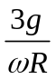, clockwise B. 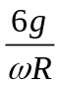, clockwise
3R
ω
C. , anticlockwise D. , anticlockwise
17. A solid sphere rotates without slipping on a horizontal surface, the ratio of its rotational kinetic energy to its total kinetic energy is
A. 28.6% B. 40% C. 66.7% D. 71.4%

18. A large tank filled with water has a pipe in the bottom (the pipe is thin enough). In steady flow, the pressure at P point is (Atmosphere is P₀):
H
H/3
P
A.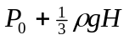; B.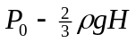;
C.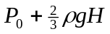; D.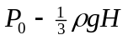;
19. There are three particles in a point-like particle system, each mass is m, and separation between the particles is d. The binding energy (the energy for separating the system) of the 3-particle system due to the gravitational force is
A. 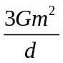 B.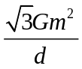 C. 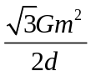 D. 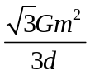
20. When a wind blows between two buildings, a significant drop in pressure can be created. The air pressure is normally 1atm inside the building, so the drop in pressure just outside can cause an attract force on the car. The density of air is 1.29 kg/m³. Under a 27m/s wind, the force exerted on a 2×3m car is
A. 2821 N B. 2632 N C. 2438 N D. 2212N
II. Calculation problems (present the necessary equations in solution):
1. Two particles combined together, the interaction potential between the particles is 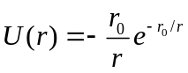. (1) What is the separation between the particles at the equilibrium condition? (2) How much energy is needed to break this particle system?

2. A small solid sphere with radius r rolls without slipping from the top of a hemispherical mound shown in the figure.
r
R
The radius of hemispherical mound is R, and R>>r. The small solid sphere starts from rest, what is the height where the small solid sphere leaves from the surface of hemispherical mound?
10R/17
3. A solid cylinder, with mass m initially at rest, is given a sharp impulse by a cue. The cue is held horizontally 5R/3 above the ground, where R is the radius of the cylinder. The cylinder leaves the cue with a speed v_{o}. (1) What
5R/3
v_{o}
is the final speed of the cylinder due to the friction force between the cylinder and the ground? (2) With the friction force, how much kinetic energy does the cylinder lose?

4. A solid cylinder with mass m and radius R is wrapped by a thin string. The string passes over a cylindrical pulley of mass m and radius R, and connects to an object with mass m. What is the acceleration of the object? 2a/3
a

